ARONA MANAGEMENT (PTY) LTD
Company Registration Number: 2011/110519/ 07, VAT Number: 4770266346
a Member of the AM.CO.ZA Group of Companies, Organize Back Office for the Group
Admin & Finance: C026 Stoneridge Office Park, 8 Greenstone Place, Edenvale 160 011 025 1446
Jet Park Warehouse: Unit 1, 2 & 3 Gateway Industrial Park, 21 Graniet Street, Jet Park 1459 011 397 1429
Postal Address: PostNet Suite #119, Private Bag X10010, Edenvale 1610, Gauteng, South Africa

Press Release for Advanced Machinery (Pty) Ltd
11th March 2015
For further information please contact:
Ms Nicole Koen
Executive Assistant
Tell: 060 600 6000 / 011 397 1429
E-mail: media@am.co.za / nicole@am.co.za
Website: http://am.co.za/

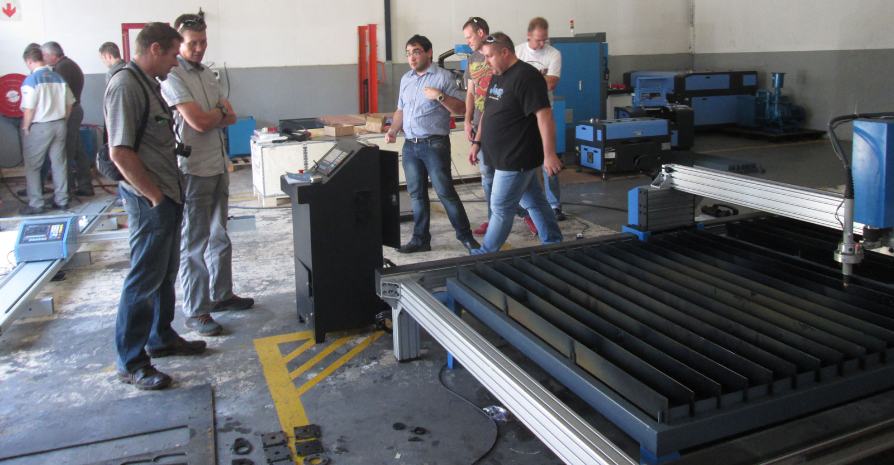
Advanced Machinery in Spotlight Again Thanks to
Next Generation MetalWise CNC Plasma Cutting Machine.

Advanced Machinery located in Johannesburg has been focusing on developing CNC technology and sales on CNC Machinery for several years. They would now like to introduce the second generation Plasma Cutting Machine to the market.

On Wednesday 11th March 2015 Advanced Machinery hosted a demonstration to show off their MetalWise CNC Plasma Cutting Machine in Jet Park.

More than 20 amused clients were standing around the MetalWise CNC Plasma Cutting Machine as they carefully watched as all kinds of shapes including the AM.CO.ZA Logo was being cut out of 6mm mild steel by the standard version of MetalWise CNC Plasma Cutter with Hypertherm Powermax 65A unit.

The clients were very satisfied with the cutting quality of the Machine and what they learned about this Plasma Cutting Technology, and had a lot of enquiries about the Machine as well as requests for quotations.

The MetalWise CNC Plasma Cutting Machine Used in the Demonstration Consists of 2 Versions as Follows:

- a Standard version of 1500x3000mm Table Size with Hypertherm Powermax 65
- a Lite version of 1500x3000mm Table Size with Hypertherm Powermax 45

You can come view this extraordinary technology among others in action at our DIY workshop in Jet Park.

Address:

Unit 1, 2 and 3 Gateway Industrial Park
21 Graniet Street
Jet Park ( GPS S 26.155838 E 28.218936 )
Gauteng

About MetalWiseTM CNC Plasma Cutting Machine:

MetalWise series of CNC plasma cutting machines are introduced into South Africa market at 2012 by Advanced Machinery. It consist several version for different market:
- MetalWise Lite: a portable, lightweight and very affordable entry level CNC Plasma cutting solution
- MetalWise Standard: suitable for most applications, our recommend CNC metal cutting solution
- MetalWise Large: our CNC metal cutting solution for supersized metal plate cutting

About Advanced Machinery (Pty) Ltd:

Since the inception in 2012, Advanced Machinery has grown profusely - from its meagre beginnings as purely a CNC machine selling agent, to an organisation that stands tall and offers comprehensive CNC machine related services. Not only do they design, engineer and supply state-of-the-art machinery, but they also source reputable suppliers from China and coordinate the entire import process in a manner that minimises the risk for them clients and places the onus on them to demonstrate our commitment to delivering the superior quality solutions that they have become renowned for. Please visit http://am.co.za/about or call 072 222 2211 for more.

About AM.CO.ZA Group of Companies:

AM.CO.ZA Group of Companies is current consist of several companies in various of sectors. All of them reflect the founder's strong sentiment that Achievement Matters. Whether referring to achievement in business, marketing, training or simply in a personal capacity, am.co.za and all of its subsidiaries are geared specifically toward helping our customers realise the potential and achieve...... For a list of the companies and the business sector they falls in, please visit http://am.co.za/ for more.

More Information:
The MetalWise CNC Plasma: http://am.co.za/plasma
Hi-Res Photos for the Event: http://am.co.za/media/machinery/metalwise-plasma-2014-march

